Name: ______________________ Date: ________________

**Intro to Algebra: Chapter 5 Review**

*Tell whether the ordered pair is a solution.*

1. (2, 3) y = 2x+ 7 2. (-3, 1) y = -2x – 5 3. (-3, 3) 

*Graph the equations using the t-chart:*

4. y = 2x - 1 5. y = -3x + 2

|  |  |  |
| --- | --- | --- |
| **Input**  **X** | **Output**  **Y** | **Work** |
| -2 |  |  |
| -1 |  |  |
| 0 |  |  |
| 1 |  |  |
| 2 |  |  |

|  |  |  |
| --- | --- | --- |
| **Input**  **X** | **Output**  **Y** | **Work** |
| -2 |  |  |
| -1 |  |  |
| 0 |  |  |
| 1 |  |  |
| 2 |  |  |

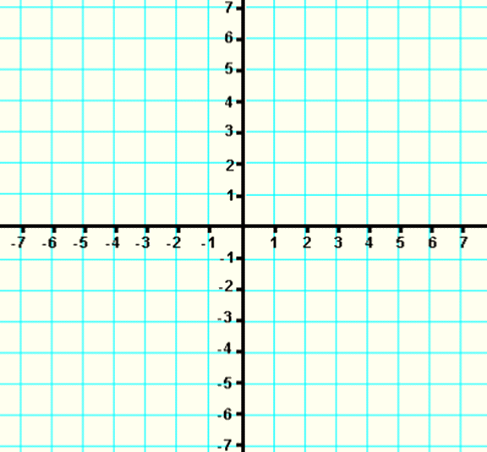 

*Find the slope of each line given the following points:*

6. (8, 3), (2, 5) 7. (-2, 5), (-2, 9)

8. (-3, -5), (9, -1) 9. (-3, 5), (4, 5)

10. (-3, 6), (-8, 4) 11. (11, -1), (14, -6)

*Determine if the following lines are parallel or perpendicular:*

12. (3,2), (4, -1) and (-1, 2), (-4, 1) 13. (4, -3), (2, -7) and (1, 2), (3, 4)

*Find the x-intercept and y-intercept:*

14. 3x – 2y = 18 15. y = -3x + 5 16. y = 2x – 7

Graph the line using the point and slope:

17. (3, -2), m= -2 18. (0, 3) m = -1/3

 

19. (-4, 4), m = 2/3 20. (0, -2), m = 3

 